# Computer Networks Lab Assignment 5

POOJA A

RA2211026050031

CSE AIML A

## Objective

* To configure static and default routing on routers to enable communication between different network segments.
* Using cisco packet tracer, to create a network with multiple routers and PCs, and configure routing to ensure proper data transfer.

## Steps taken to set up the network

### Step 1:

Select and drag required network devices (2 Router-PTs, 2 2960-24TT Switches) and end devices (2 PC-PTs).

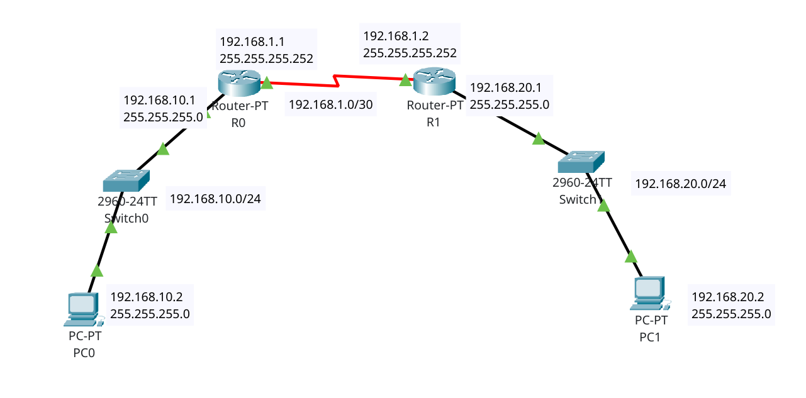

### Step 2:

Open Routers and add PT-ROUTER-NM-1CFE and PT-ROUTER-NM-1S Modules.

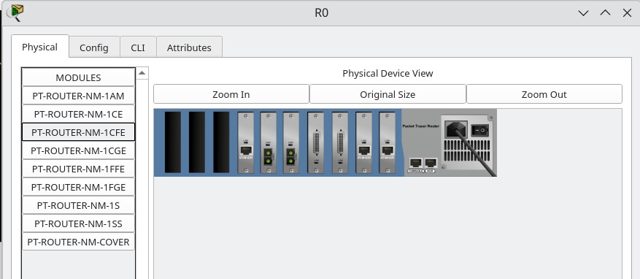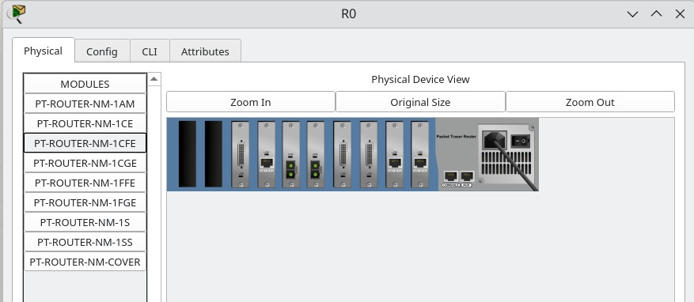

### Step 3:

Connect the cables (Straight through cables for different devices) and Serial DCE (between routers).

### Step 4:

Open the routers CLI and type in the following commands (R0)

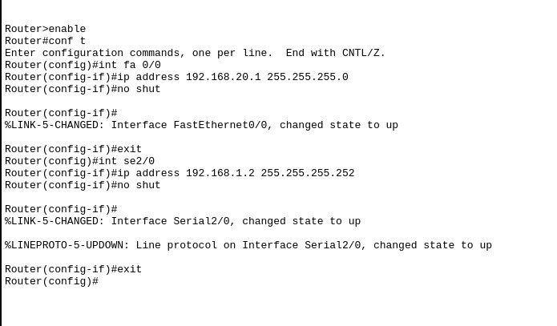Similarly do it for R1.

### Step 5:

Configure IP addresses for PC1 and PC2

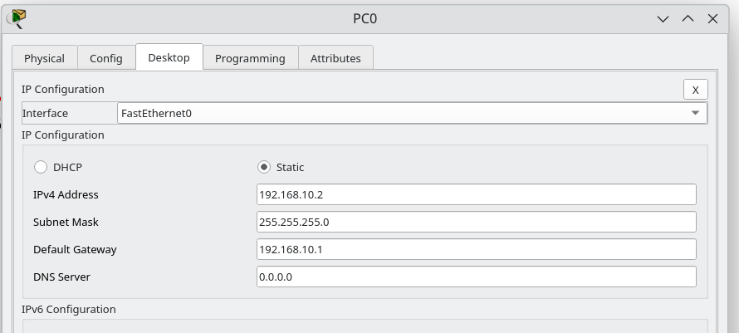 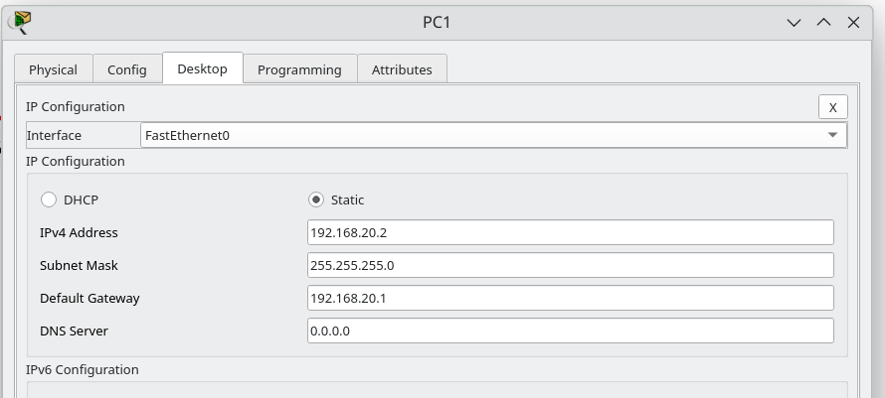

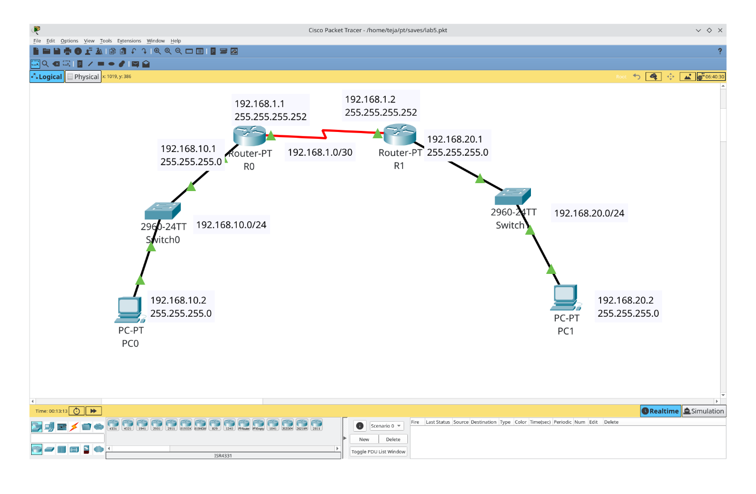

### Step 6:

Configure Static Routing and Default Routing for Routers.

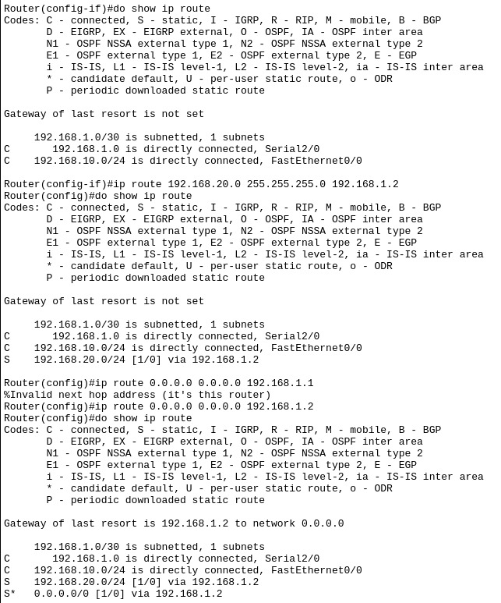

This is for R0, Implement the similar for R1 (default and static pointing to R0).

## Simulation:

Pinging PC1 from PC0

ICMP ECHO RESPONSE:

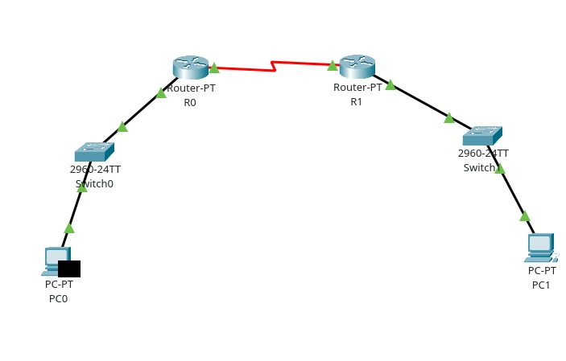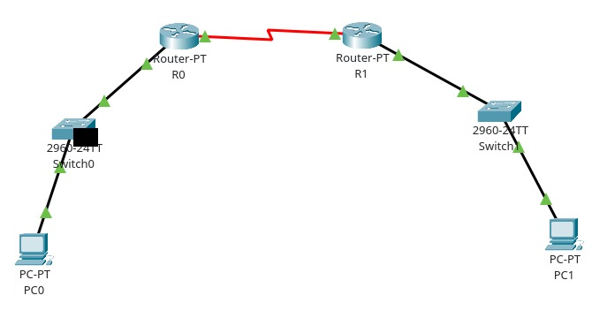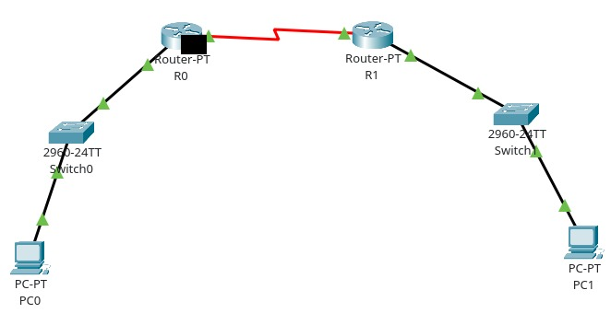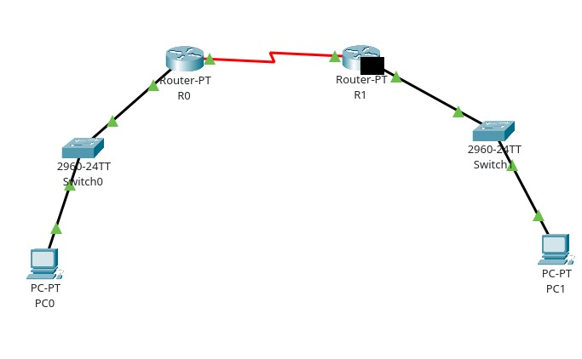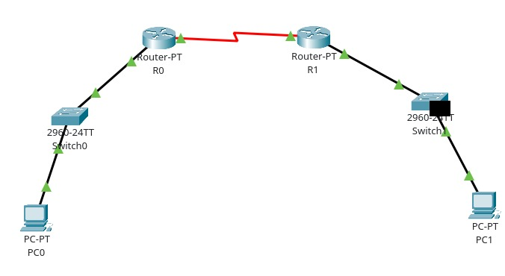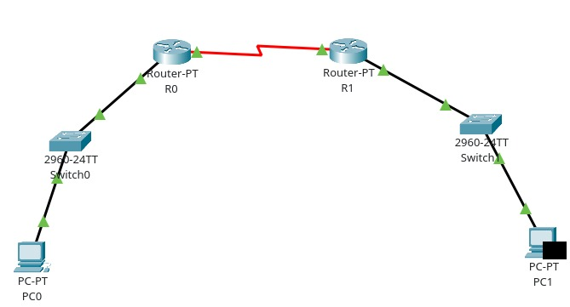

ICMP ECHO REPLY:

